Exploring the Career Interest Explorer Results
- Log Into Naviance: www.naviance.com
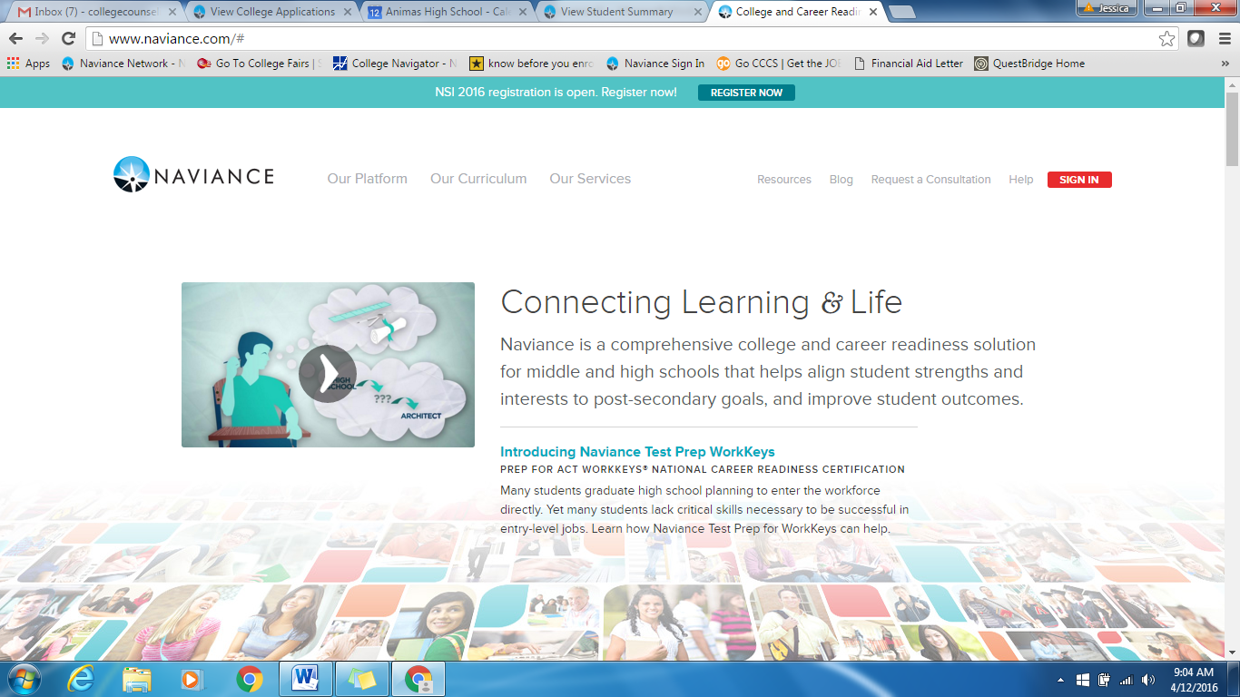
Click here!
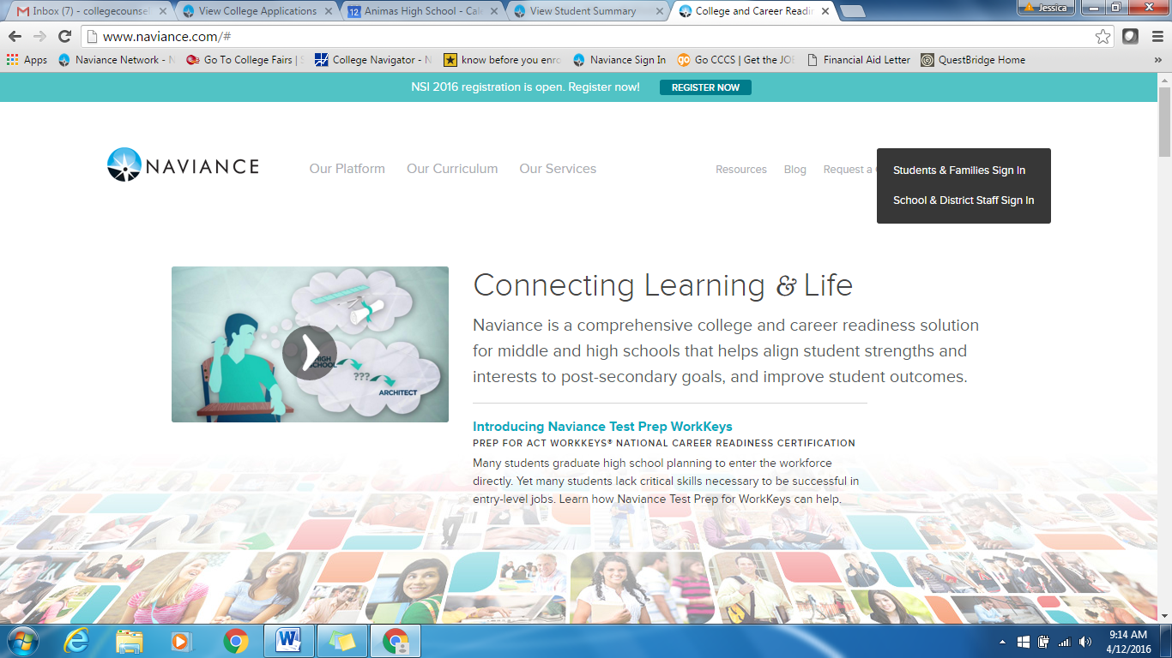
Select Students & Families Sign In
2. Log In
Postal Code: 81301 Select- Animas High School
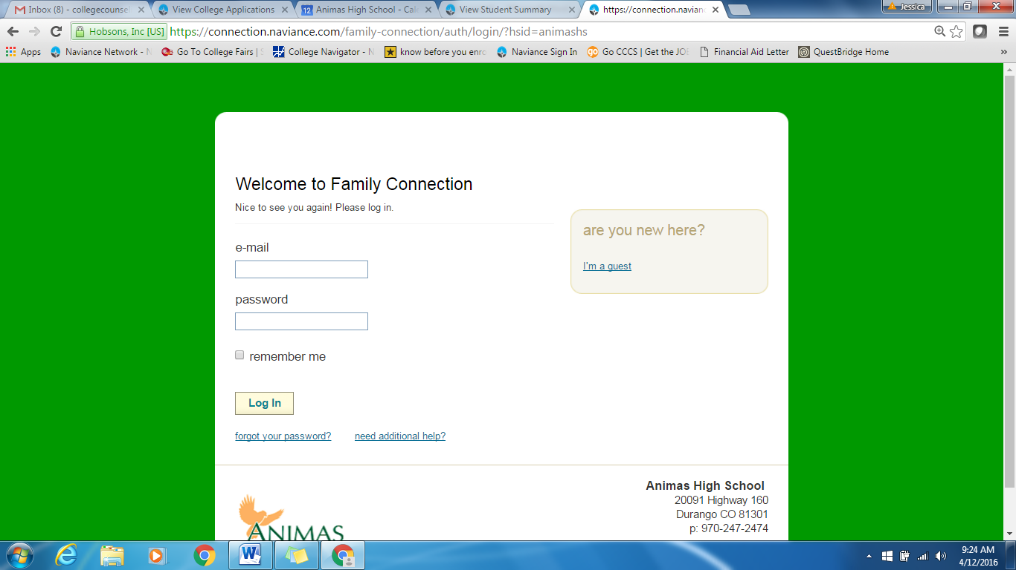
Animas Email
Password: ahs2018
A
3. Click on the Career Tab
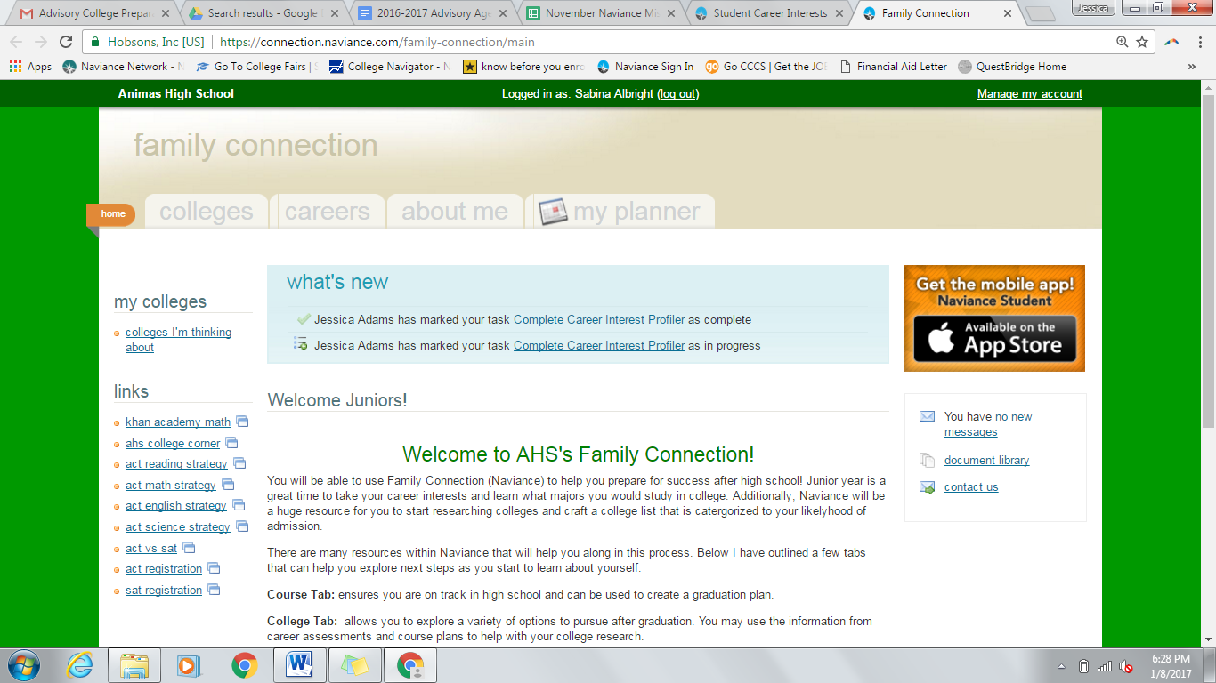

Click Here!
4. Select Career Interest Profiler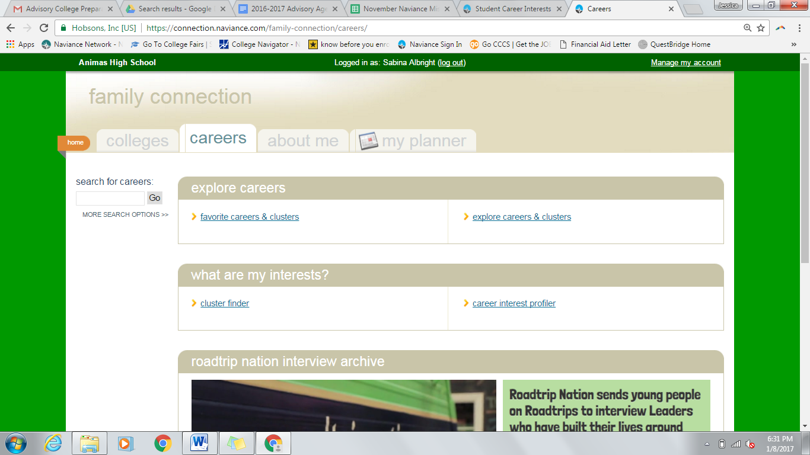
Click Here!

5. Review your strongest areas in green. Then click on the Viewing Matching Occupation List
- Read the different descriptions for each of the green results for you. Which one do you feel is the most accurate type of work you would enjoy. Which one do you feel is the least accurate type of work you think you would enjoy.
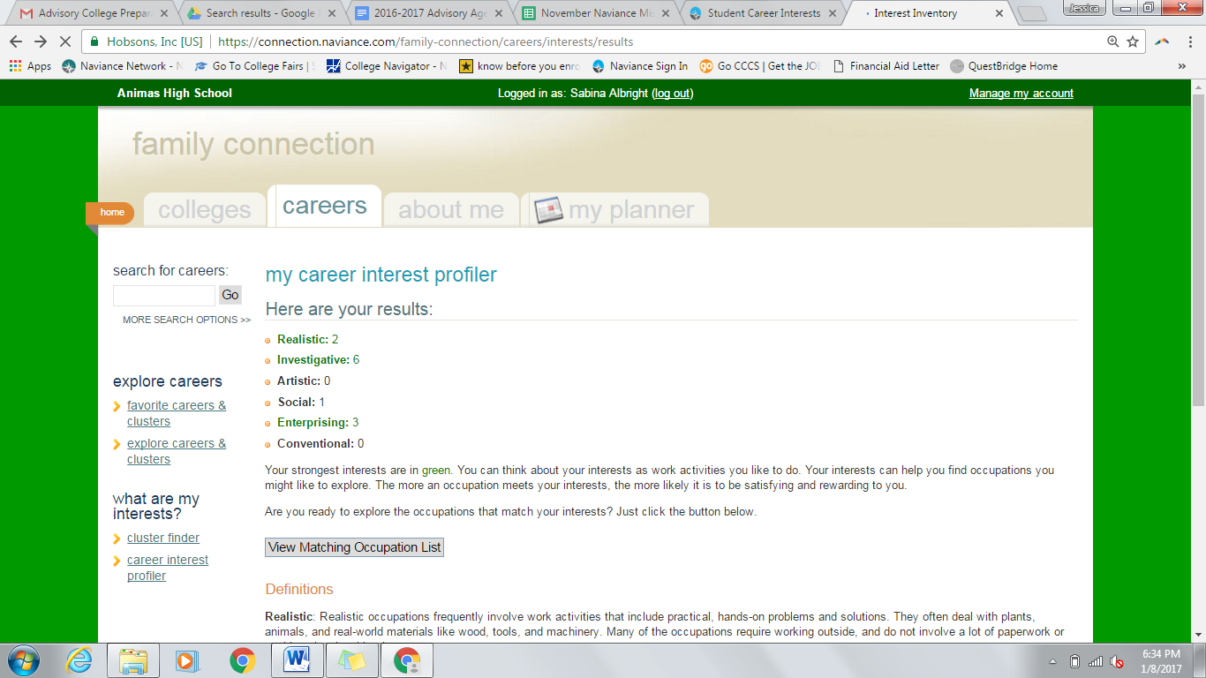
Click Here!

6. Suggested Careers that match your interest strengths are listed.
- Click on each of the question marks to learn what type of preparation is required for the careers listed below.
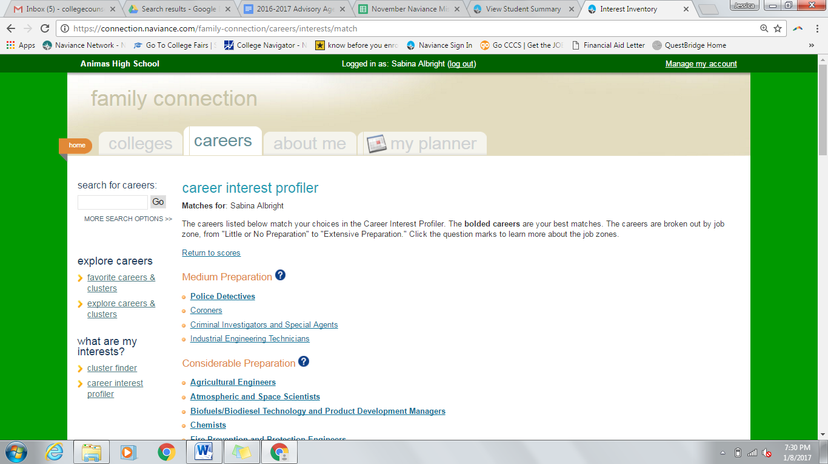
7. Start exploring a career that you might be interested in. Click on the career
- Under the overview, tab notice the related college majors. Majors would be what you would need to study in college in order to be eligible to apply for that type of career.
- Click on additional tabs to learn about what daily activities are, what a typical wage would be for the career.

